Version 2.0

Abarna Kucheri Subburaman

EECS 2311 – Group 6

York University

User Manual

Authoring App

Table of Contents

A. Overview 3

1. Brief Background of Software 3

B. Getting started 3

1. Command Prompt 3

2. Application Icon 3

C. Accessibility 4

1. User Access 4

D. Program features 4

1. HomePage 4

2. Play a Scenario 5

3. Create New Scenario 6

4. Edit a Scenario 6

E. Button actions 7

1. Insert Number of Cells 7

2. Insert Number of Buttons 7

3. Add a sentence 7

4. Pause 7

5. Display a Sentence 7

6. Insert Sound 7

7. Sentence to Repeat 7

8. Insert Repeat Button 7

9. Insert Skip 7

10. Add header to section for Skip 7

11. Indicate Scenario for User Input 7

12. Reset buttons in Scenario 8

13. Clear All Cells 8

14. Display Clear Cell 8

15. Set pins for Cell 8

16. Display character in cell 8

17. Raise single cell pin 8

18. Lower single cell pin 8

19. Delete a Line 8

20. Edit Line 8

21. Back to Home 8

22. Save and Close 8

# Overview

## Brief Background of Software

|  |  |
| --- | --- |
|  | The Authoring App software is developed as a learning tool for the visually impaired students. More specifically, it is a tool designed for the educators to utilize and provide students opportunities to learn about braille cells and their functions in class. It is an interactive program where the educator can create customized scenarios to play in class. It also gives the educator an opportunity to understand how to input text and design scenario files in an effective manner in order for the program to comprehend entered content. In addition, educators can edit existing scenarios and play several variations of the scenario. Educators can review the previously created scenario on the screen for proof reading purposes. In the current phase of the project, the software is only designed to incorporate simulations of the braille cells due to hardware shortage for prototypes. |

# Getting started

Project will be delivered as a JAR file. There are two methods of running the program.

## Command Prompt

|  |  |
| --- | --- |
|  | Instructions:   1. Open up a command prompt window 2. Navigate to the AuthoringApp.java file within the Enamel Project Directory. If on windows, the “dir” and “cd” commands can be used to list the contents of a directory and change directory, respectively. 3. Compile the program by typing “javac AuthoringApp.java”, press enter.   Execute the program by typing “java AuthoringApp.java”, press enter. Alternatively, user can also run program from the terminal in Linux. |

## Application Icon

|  |  |
| --- | --- |
|  | Once you have downloaded the JAR file onto your device in the desired location, simply double-click the application icon to run the authoring app program. If the program fails to execute, check your firewall settings and other software that have the potential to stop programs from running. If you are still having trouble, contact the project developers for assistance. |

# Accessibility

## User Access

|  |  |
| --- | --- |
|  | The accessibility is catered primarily to the visually impaired students. The program provides the ability for screen readers to interpret the contents displayed.  Note: It is **highly important** that users download and enable screen reader prior to program execution.  The accessibility features for this program require no extra steps aside from screen reader installation. In the future, client can expect a feature where user can turn off the accessibility if it is not needed. |

# Program features

|  |  |
| --- | --- |
|  | The Authoring App has three main features:   * Create a Scenario – create a fresh new scenario * Edit an Existing Scenario – open up a previously created scenario and append additional questions or make changes to existing event * Play a Scenario – select a scenario file from your directory and play it through the Treasure Box Braille simulator |

## HomePage

|  |  |
| --- | --- |
|  | The main menu hosts the access to the program features mentioned above. The Play Scenario button will open a file chooser where you can select the scenario file to simulate. The Create New Scenario button will open a new window where you can add various events to save and create a new scenario file. The Edit a Scenario will also open a file chooser where you can select the scenario to edit. The Exit app closes the application. |

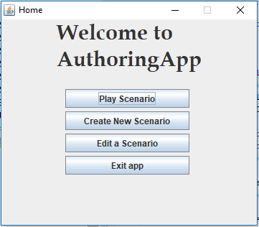

Figure 1: The main menu window for Authoring App

## Play a Scenario

|  |  |
| --- | --- |
|  | Clicking on this button will open a file chooser for user to select the scenario file to run in simulation. |

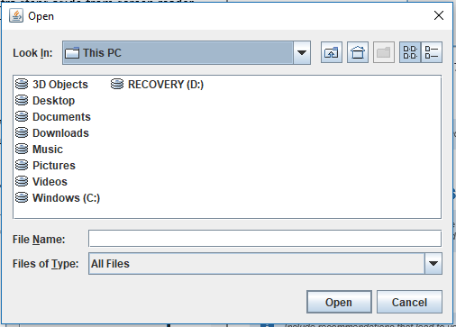

Figure 2: File Chooser to play a selected file

## Create New Scenario

|  |  |
| --- | --- |
|  | Pressing the Create New Scenario button will lead you to the Create Scenario window. This window has numerous action events you can add to the scenario. Refer to the Button Actions Section in the Manual for more details on what each button feature in this window does. Once you have finish adding events in the scenario, click on the Save and Close File button to save the scenario file with a name of your choice and return to main menu to play saved scenario. |

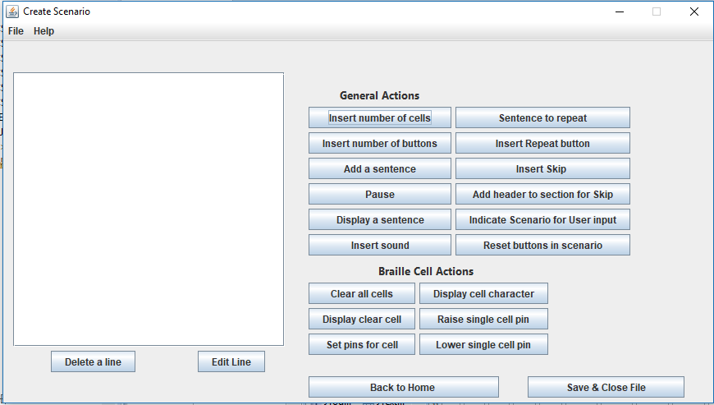

Figure 3: Create Scenario Window

## Edit a Scenario

|  |  |
| --- | --- |
|  | Pressing the Edit a Scenario button will open a file chooser to select and open existing scenario file. Once a file is selected, you will be lead to a screen similar to the create window and the list on the window will be loaded with the events in the file. From there, you can make and save changes to the file accordingly. |

# Button actions

## Insert Number of Cells

Tells the machine how many cells are used throughout the scenario.

## Insert Number of Buttons

Tells the machine how many buttons are used throughout the scenario.

## Add a sentence

Adding a sentence tells machine to interpret and orally present to user.

## Pause

Tells the machine to pause for the specified number of seconds.

## Display a Sentence

Tells the machine to display the specified sentence and present it on the simulation window.

## Insert Sound

Add a sound file as a response to the answer in scenario.

## Sentence to Repeat

Tells the machine to store this sentence to repeat to audience when user presses the repeat button.

## Insert Repeat Button

Assign one of the buttons to repeat the sentence stored under repeat command when pressed. It repeats the sentence that was stored latest in the scenario.

## Insert Skip

Tells machine which header section to skip to when the assigned button is pressed.

Caution: The header specified in this event must match one of the headers present in the scenario.

## Add header to section for Skip

Essentially a title that is assigned typically at the beginning of the new question/event. It is the section that program jumps to when the assigned skip button is pressed.

## Indicate Scenario for User Input

Tells machine to wait for a response from the user which is typically a button click.

## Reset buttons in Scenario

Removes all assignments for the buttons in the scenario.

## Clear All Cells

Clear all braille cells in scenario keeping the individual pins for each cell at a lowered state.

## Display Clear Cell

Select a cell to clear pin assignments.

## Set pins for Cell

Referring to the braille cell image, which can be viewed by pressing the View Braille Cell Button, assign pins in a cell 1s and 0s to have custom display.

## Display character in cell

Assign a braille cell to display a character on screen.

## Raise single cell pin

Select a cell of choice and enter the specific pin number which you would like to raise.

## Lower single cell pin

Select a cell of choice and enter the specific pin number which you would like to lower.

## Delete a Line

Select an item on the list of added events and press this button to remove selected event from list.

## Edit Line

Select an item on the list of added events and press this button to modify the event. You can also select item and click on a different button action to replace the selected action with new one.

## Back to Home

Returns to the main menu of this app.

## Save and Close

A standard save dialog is opened and you can enter the name you would like to save the scenario file under. Once okay is pressed, it prompts user on whether they want to return to main menu.